Set the isolation level to SERIALIZABLE and demonstrate
concurrent transaction behavior using two sessions.
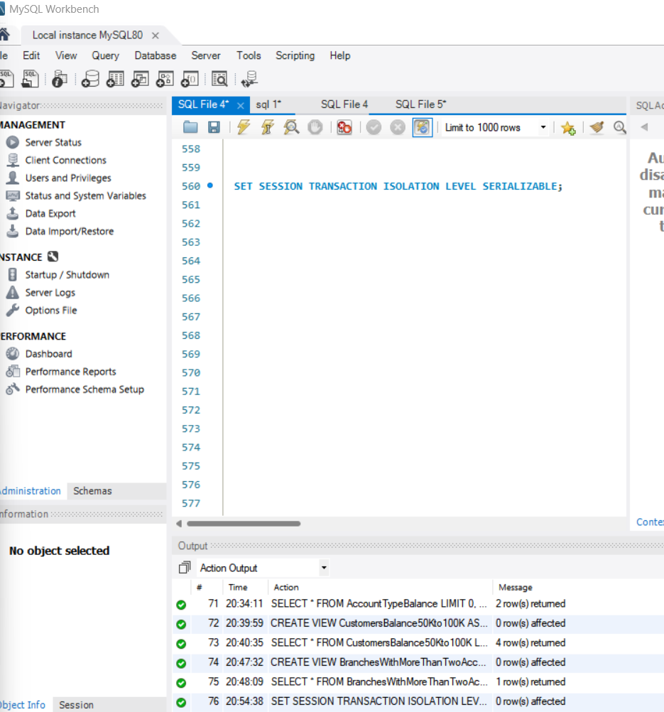

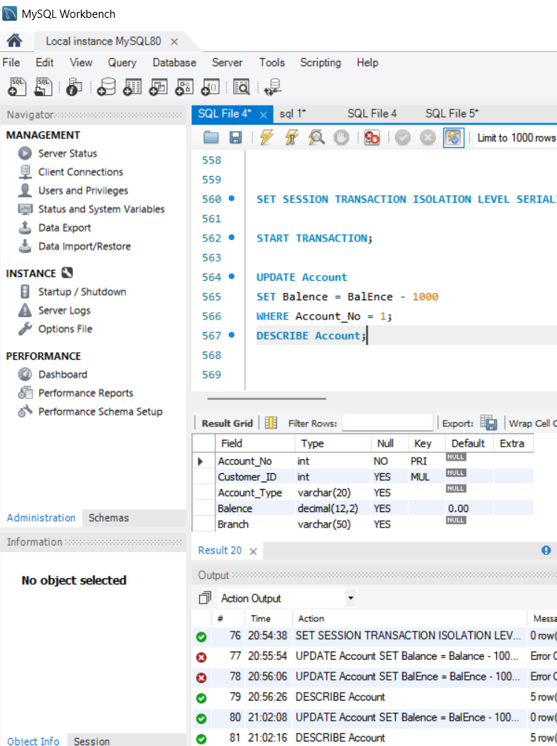

Set the transaction isolation level to READ COMMITTED and
demonstrate that an uncommitted update cannot be read.
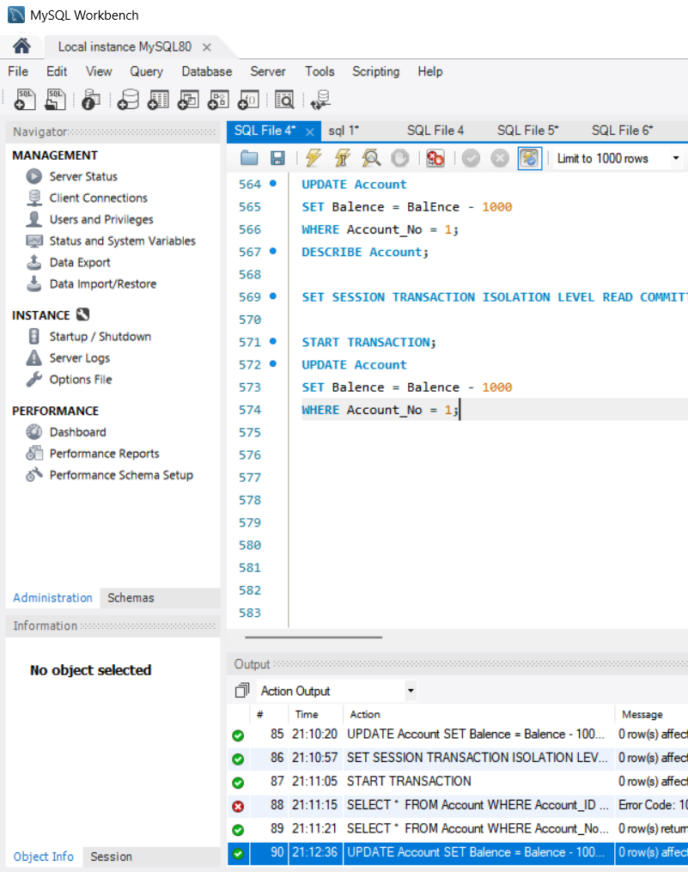

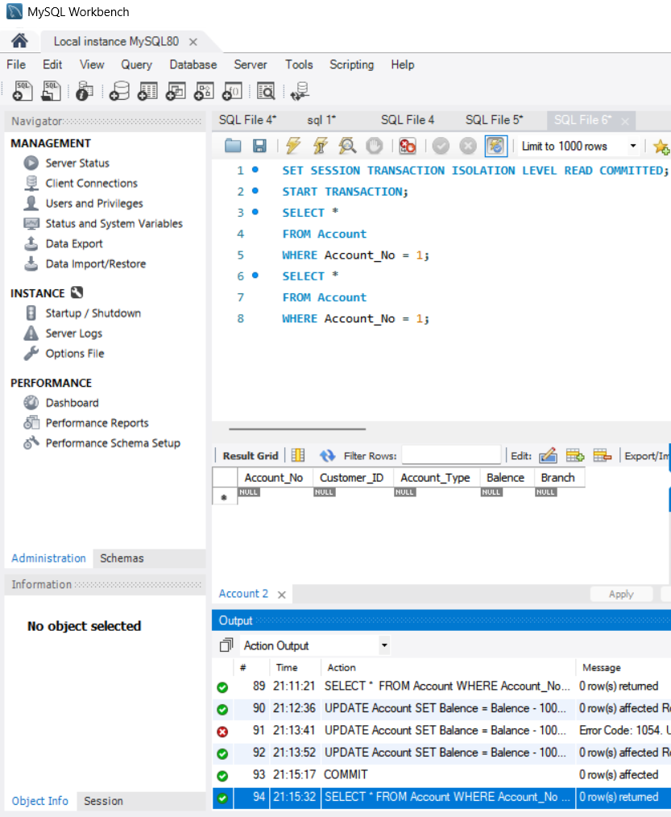

Create a transaction that deposits Rs. 5000 into account 10001 and commit the transaction.

